You Must Be Born Again John 3:1-8
I. Introduction
A. In John Chapter 3 Jesus Taught Nicodemus, a Pharisee how to be “Born Again” or “Born of God” (How To Be Added To The Coming Kingdom Of God)!
B. John 3:1-8 A Summary Of Events..
- Nicodemus, a Pharisee, a religious leader of the Jews came to Jesus by night professing faith in Christ stating “"Rabbi, we know that You are a teacher come from God; for no one can do these signs that You do unless God is with him."
- It was then that Jesus told Nicodemus that he needed to “Be Born Again” , Jesus said in v3 "Most assuredly, I say to you, unless one is born again, he cannot see the kingdom of God."
- Nicodemus (who misunderstood what Jesus meant said) stated "How can a man be born when he is old? Can he enter a second time into his mother's womb and be born?"
- And Jesus Answered…, "Most assuredly, I say to you, unless one is born of water and the Spirit, he cannot enter the kingdom of God. 6 That which is born of the flesh is flesh, and that which is born of the Spirit is spirit. 7 Do not marvel that I said to you, 'You must be born again.'
C. Jesus was not speaking of a fleshly, physical birth, but of a Spiritual Birth (Being Born of God)!
II. Jesus Teaches That There Are 2 Parts To This “New Birth” Being Born Of Water and Of The Spirit!
A. BEING BORN OF THE SPIRIT = Refers To Hearing and Receiving The Truth, or The Word Of God Inspired By The Holy Spirit! John 6:44-45, John 8:31-32
**I Peter 1:23-We Are Born Again Through THE SEED OF GOD! There are 2 Types of Seed: Corruptible Seed = The Word or Doctrine of Man which leads To Destruction! Incorruptible Seed = The Word or Doctrine of God which leads To Salvation or “The New Birth”
**Notice That Seed Only Makes That Of Its Own Kind! ….Watermelon Seed only produces Watermelon! Corn Seed only produces Corn! Tomato Seed only Produces Tomatoes!
**Notice That Religious Doctrine (Seed) Only Makes That Of Its Own Kind! Baptist Doctrine (Seed) combined with Baptism = makes one A Baptist! Catholic Doctrine (Seed) combined with Baptism = makes one A Catholic! Methodist Doctrine (Seed) combined with Baptism = makes one A Methodist! Jeh Wit Doctrine (Seed) combined with Baptism = makes one A Jeh Witt! Mormon Doctrine (Seed) combined with Baptism = makes one A Mormon! God’s Doctrine (Seed) combined with Baptism = makes one A CHRISTIAN!
B. BEING BORN OF WATER = Submitting Oneself To Water Baptism Commanded By The Lord (Matt 28:18-20)
**Acts 8:35-39 Notice That The Eunuch Obeyed Water Baptism after Hearing The Truth From Philip. Thus, The Eunuch was “Born Again” or “Born of God” having received the Truth and Obeying The Command to be Baptized!
III. God’s History Of Saving/Healing Through Water!
A. I Pet 3:18-21 Noah and His Family Were Saved Through Water!
B. I Cor 10:1: The Children Of Israel Were Delivered From Bondage Through Water!
C. 2 Kings 5:14 Naaman was cleansed from his leprosy through water!
D. Acts 2:38, Acts 22:16 God saves us today through water!
E. I Pet 3:21 Peter teaches that baptism saves us!
IV. The Examples Of Conversions In The Book Of Acts
**Notice In Every Conversion In Acts People Heard/Received The Truth and were Baptized!
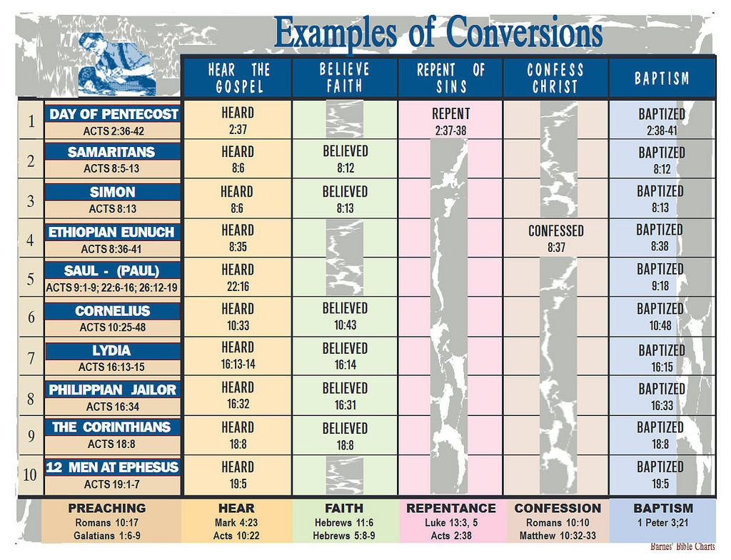
V. The Evidence Of The New Birth!
A. John 3:7-8 Like the wind we cannot see The Spirit, however, we can see the effects in our lives!
B. Gal 5:22-23 We Produce “The Fruit of The Spirit” …Love, Joy, Peace, Patience, Kindness, Goodness, Faithfulness, Gentleness and Self-Control!
C. Gal 5:16, Gal 5:25-We “walk in the spirit”

